# Island Wars: AR – Onboarding

## *Currently in phase 1*

## NYU AR and VR and 3D Graphics Capstone

Thomas Bales

5/3/22

## Instructions and Capabilities by Phase

### *Movement – Phase 1*

The goal is to destroy your opponent. This is accomplished by navigating the arena by using forward thrust, braking, and rotating right or left (see figure 2). Currently for the forward and reverse movement, a Vector3 is added to the island transform. When more movement testing and refactoring occurs, the movement system will likely be force based. Below are the movement controls.

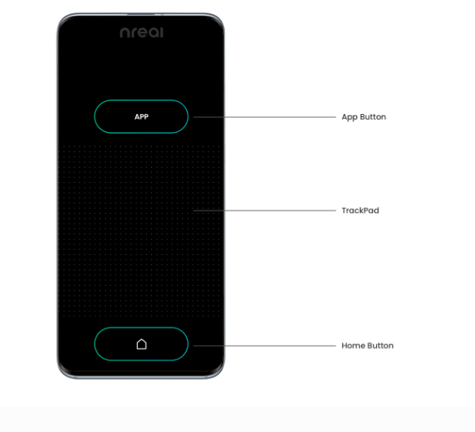

Reverse

Rotate Right

Rotate Left

Forward

Finger Gestures to Move Island

*Figure 2*

### *Weapon Firing – Phase 2*

Weapons are fired from the phone controller. Each island has four firing locations. These are, port, starboard, aft, and bow, which translates to left, right, rear, and front. There is a selection model above each ship and represents the direction of the weapon system. To select a weapon side, press the **APP** button to choose the next weapons platform. The selection is clockwise. Tapping the trackpad without swiping will fire the weapon system. Development note, this has to be tested and there is a dead zone in the code to prevent firing while using the movement system. It is likely that a custom button will be needed above the app button (see figure 3).



Tap Trackpad -> Fire Weapon Selection

App Button -> Weapon Side Selection

*Figure 1*

### *The Arena – Phase 1 and 2*

A major strategic portion of the game is to outmaneuver your opponent and put yourself in the most opportune location to give your opponent the maximum amount of damage while taking the least. To do so, you will need to navigate around floating rocks, whirlpools, and other hazardous objects. Additionally, the arena has bounds and is marked by red squares and red globes. Below are the items have been or need to be developed. Whirlpools - complete

* Floating rocks - complete
* Radiation zones – to be developed
* Arena markers - complete
* Lightning – in development

### *Tech Tree -Phase 2*

All ships will have the ability to advance their technology over time dependent on arena powerups or by allocating resources. These are categorized by levels 1 to 3 with 3 being the highest. Essentially, these are multipliers to movement, weapon damage, damage absorption, and weapon functionality. They are classified as.

* Movement
* Damage
* Armor
* Weapon Tech

Note: Weapon tech functionality is classified as dumb, smart, and AI. Dumb is unguided, smart is semi guided, and AI will hit the opponent no matter what.

### *Weapons Systems – Phase 1 and 2*

Weapons are placed in one the following locations. Weapons have a power rating dependent on location. These are 4 for the front, 2 on the sides, and 1 for the rear. The higher the rating the more damage it can do.

Below are the following systems that are or will be available.

* Torpedoes – in development
* Lightning – in development
* Lasers – to be developed
* Rail guns – to be developed
* Attack fighters – to be developed

### *Armor Systems – Phase 2*

Armor plates will be included in the final product. Their purpose is to prevent damage from weapons and provide more strategy when it comes to movement. These should have the following characteristics.

* Energy absorption
* Mass absorption

### *Resource Management – Phase 1 and 2*

The island has resources which can be extracted to give the player an advantage. There can only be 3 resource managers on each island at a time. It is up to the player what they want to gather. Below are the resources and what the benefit that each gives to the island.

* The oil - supplies the island with thrust and once the supply is depleted the player can no longer move until replenished.
* Forest – supplies the island with health over time
* Stone – supplies the island with materials to replenish weapons charges and materials from minerals